PES University, Bengaluru 

(Established under Karnataka Act 16 of 2013)

Department of Computer Science & Engineering Session: Jan - May 2022

**UE19CS353 – Object Oriented Analysis and Design with Java Theory ISA (Mini Project)**

Report on

**E-Commerce Application using REST API and Android**

By:

**Raghav S K – PES2UG19CS312**

**Rahul B – PES2UG19CS313**

**Rahul Radhakrishna – PES2UG19CS314**

6th Semester E Section

**Table of Contents**

1. Project Description

a. Link to Github repository

2. Analysis and Design Models

3. Tools and Frameworks Used

4. Design Principles and Design Patterns Applied

5. Application Screenshots

6. Team member contributions

7. Conclusion

8. References

**Project Description**

The project focuses on Designing and developing an E-Commerce Application adhering to SOLID principles and using Design patterns where applicable.

The major use cases of the project include

* **Login Registration and Authentication**  
  The application will provide a User friendly interface to register  
  themselves on the application. A username and a password will be finalized after registration. Using the username/email and password the user will be able to login and use the features of the application. In summary, a proper authentication service will be provided.
* **Product Listing**  
  Many Products will be listed on the application. Each product will have an image and other details like pricing, description like color etc. The user can check each product and find the ones which he/she likes.
* **Adding to a Cart**  
  The user can choose each product and add the ones he/she wants to buy onto a cart. The Cart will store all the products the user adds. The user can also view all the products in the cart and remove if not needed.
* **The “Buy” feature**  
  The user can buy the products as well. The final amount will be specified and then the delivery address and the details will be prompted. A final summary is then generated and the products are part of the orders that the user has undertaken.
* “**Search”**  
  The user can search the products based on name and category. The products will be filtered and only relevant products matching the name can be viewed. The products can then be selected and added to cart for buying.
* **Product Listing based on Category**

The products will be listed based on the category provided by the user.

Link to Github Repository - https://github.com/raghavsake/E-Commerce-Spring-Boot-Hibernate-REST-API-with-Android-Application

**Analysis and Design Models**

**Tools and Frameworks used**

1. Backend REST API built using
   * Spring Boot Framework
   * Hibernate ORM Framework
   * Database - MySQL
2. A front end UI built using
   * Android Java

**Design Principles and Design Patterns Applied**

A Client-Server Architecture is followed where the client is an Android application built using Android in Java.

The Server side application is built using the SpringBoot Framework which internally interacts with the Hibernate ORM Framework and MySQL Database.

Architectural Patterns used in this project are

* Model – View – Controller (MVC) for the Server
* Model – View – ViewModel(MVVM) for the Client

**MVC in Server**

* Model Class – Product Class
* Controller – ProductController Class
* View – as Android Views

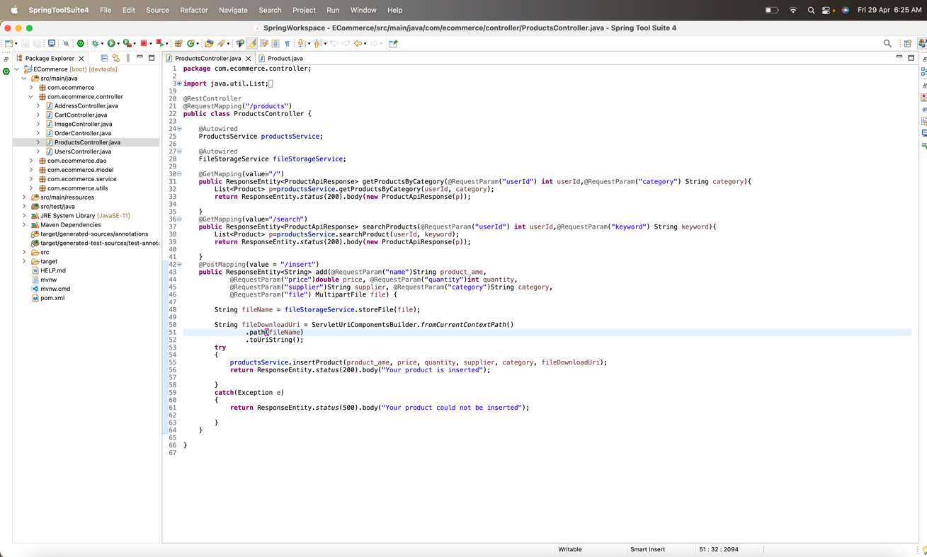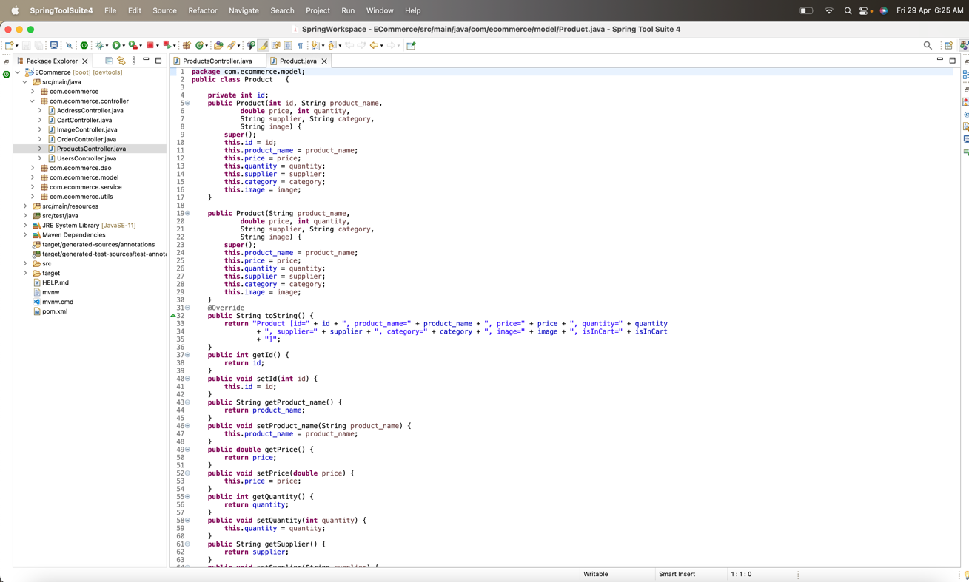

MVVM in Client

* Model class – LoginApiResponse class

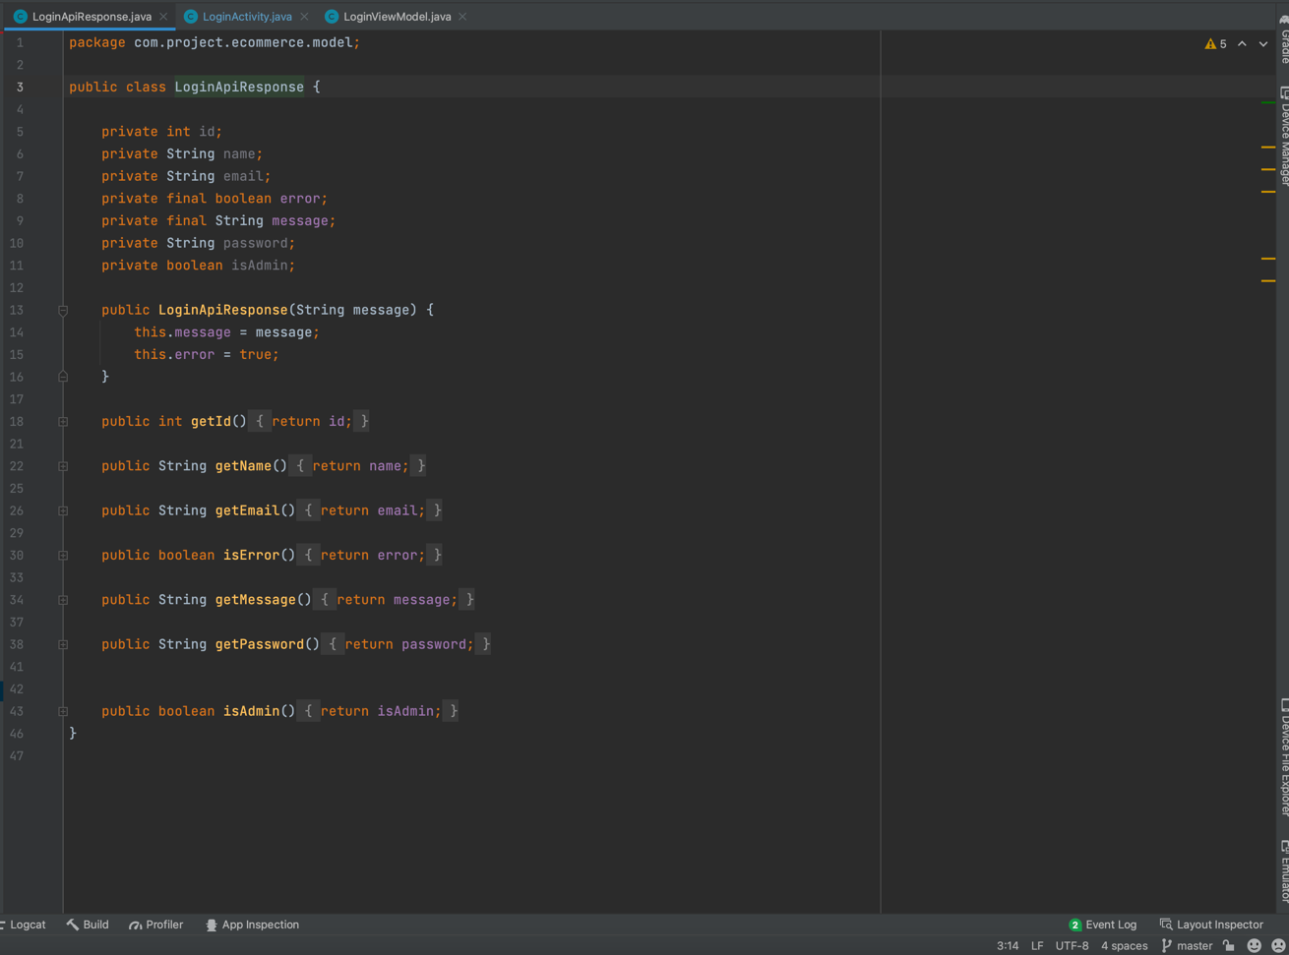

* ViewModel class – LoginViewModel class

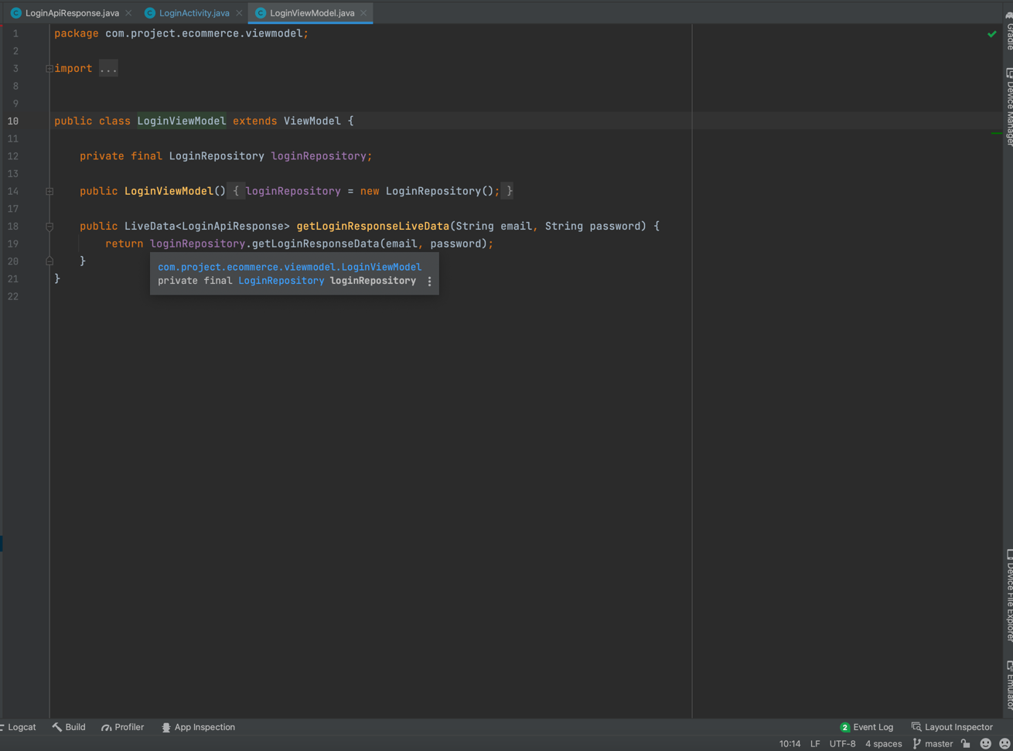

* View class – LoginActivity class

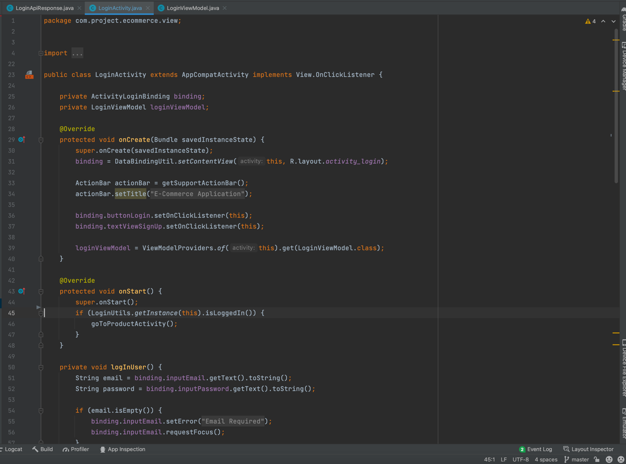

Design Patterns can be classified as internal and external.

The frameworks of SpringBoot and Hibernate and Android internally use these design patterns

* Factory – SessionFactory
* Singleton – Autowired, DispatcherServlet
* Observer – LiveData in ViewModel

We have implemented design patterns externally in the project. They are

* Singleton – Retrofit Client

The Retrofit API is used to connect the Client with the Server and we built the Client class as a Singleton to provide a single point of entry for network API Calls

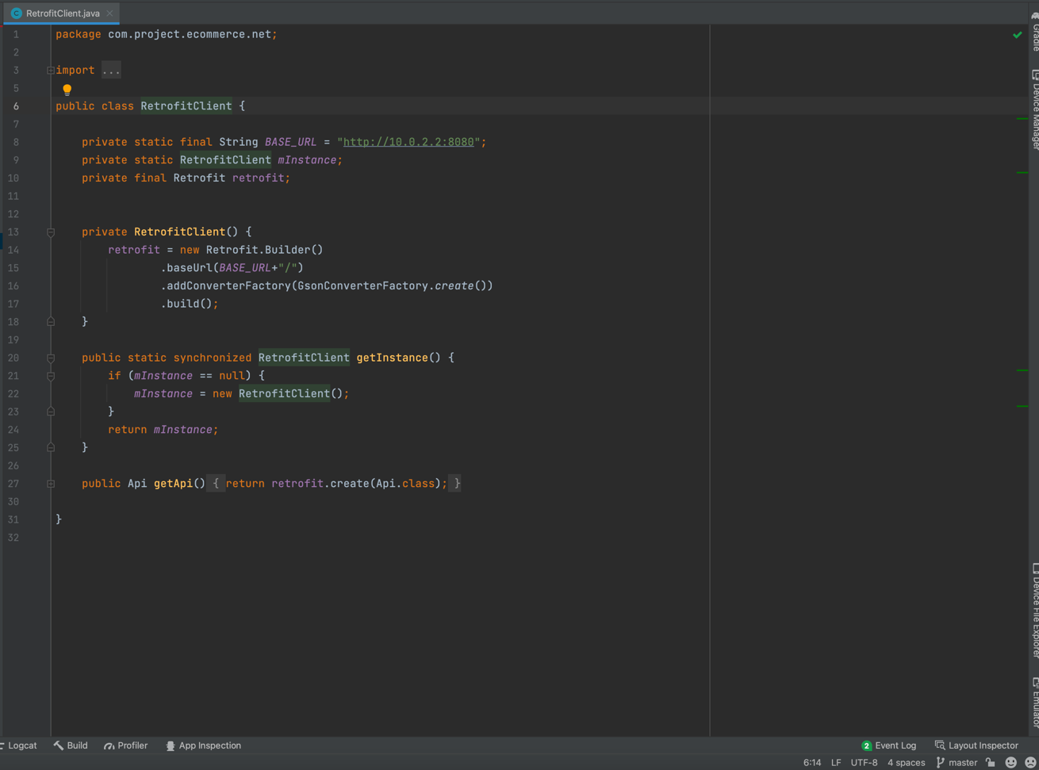

* Factory

The PageKeyedDataSource library interface is used for incremental loading of data.

The ProductDataSource implements the above interface and a factory class is created to initialize and set the DataSource as the MutableLiveData data holder.\

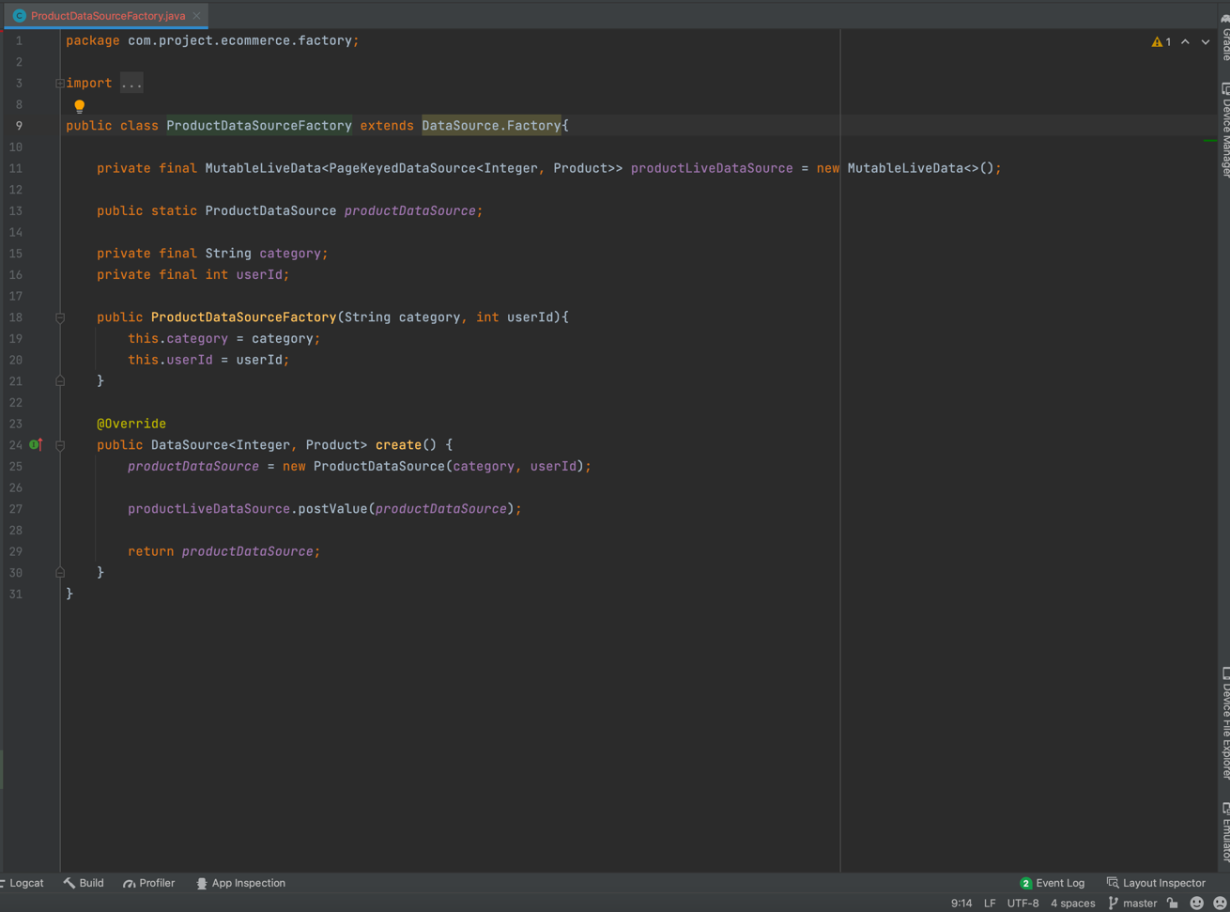

* Adapter

The Adapater acts as a bridge between the AdapterView and the Data that needs to be displayed or used in that view. In our project we have used adapters to act as a bridge between the RecyclerView for products and the List of products which is displayed in the RecyclerView

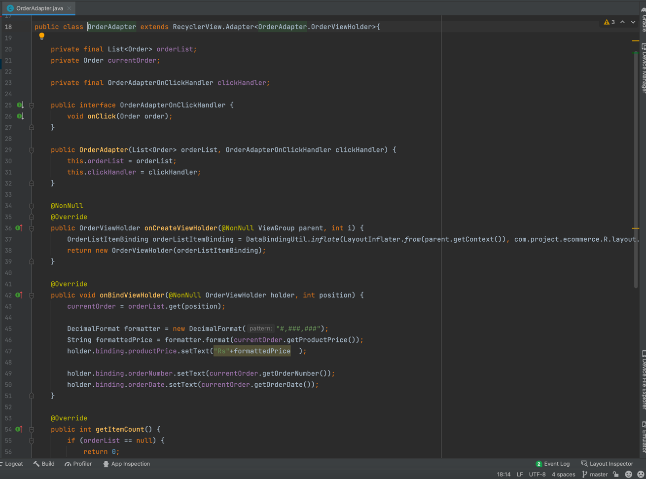

**Application Screenshots**

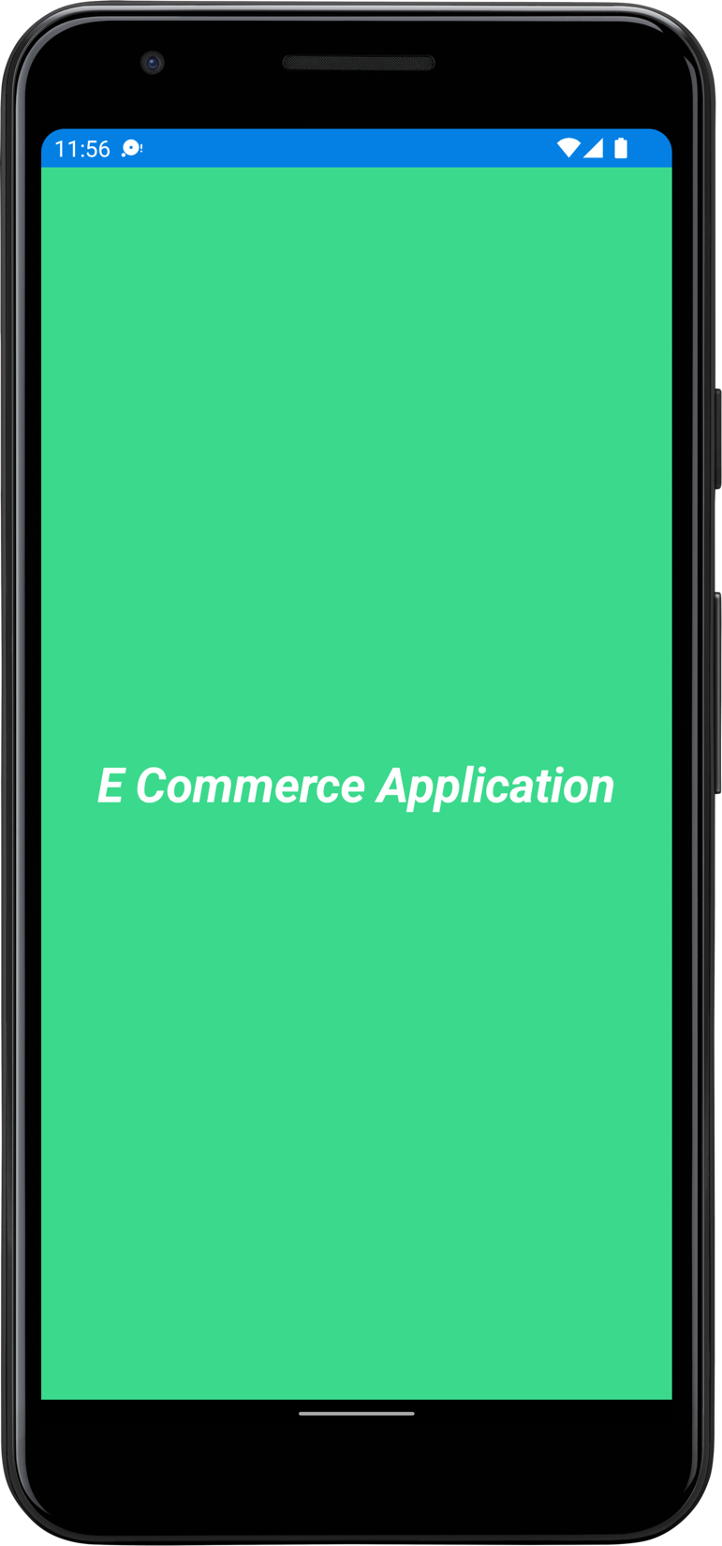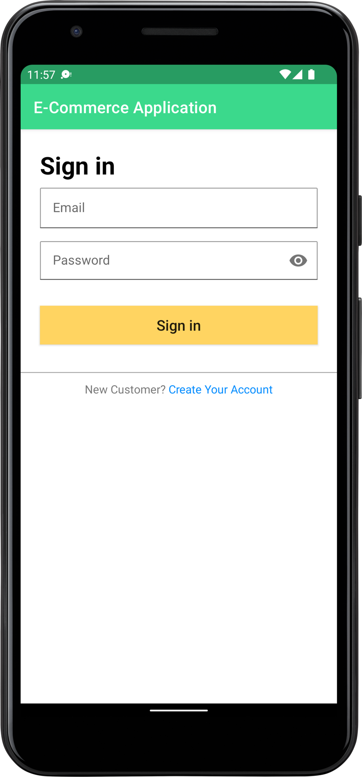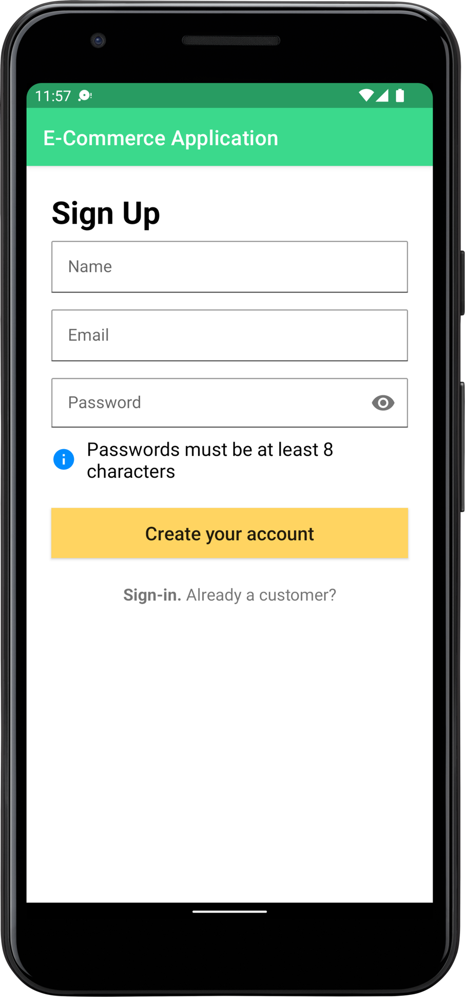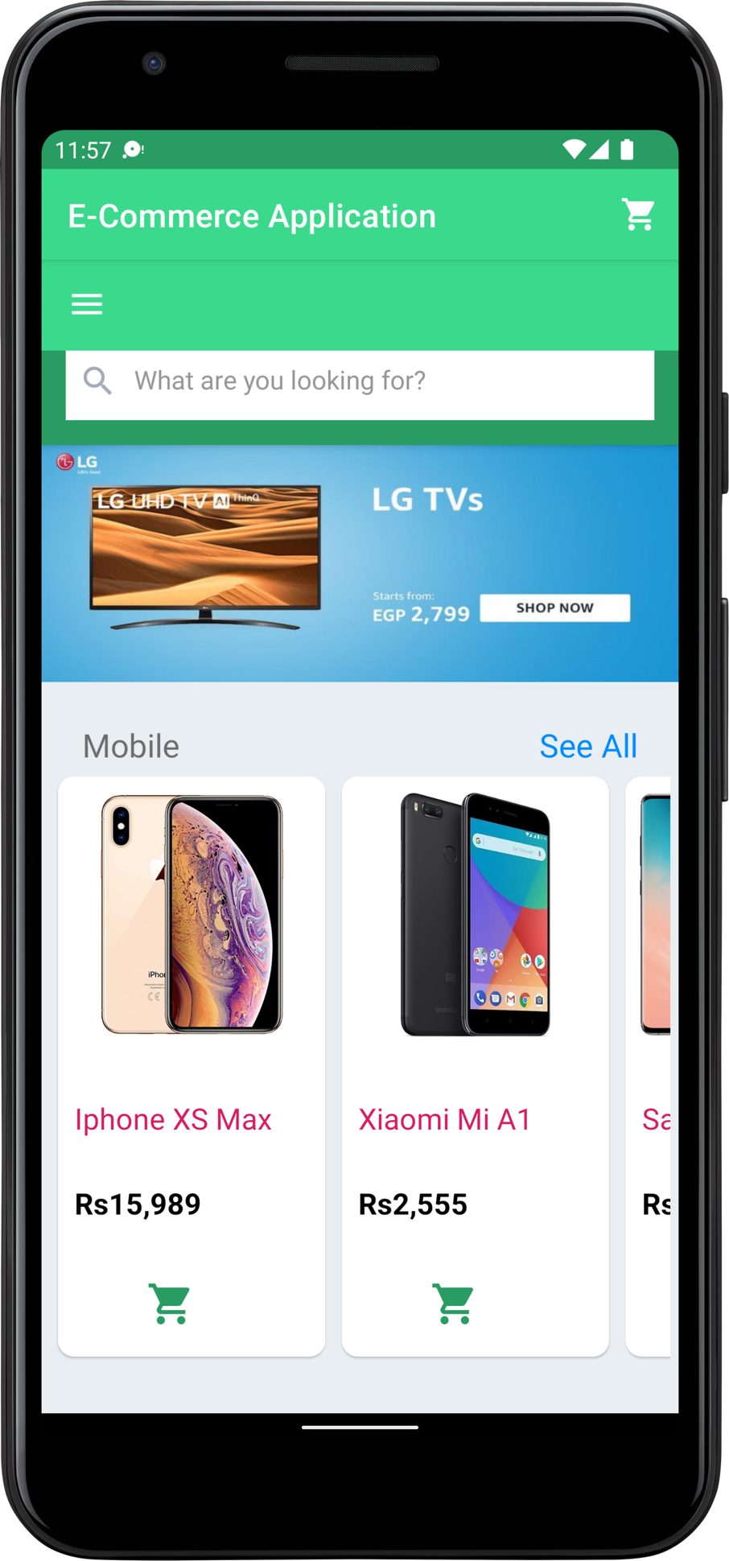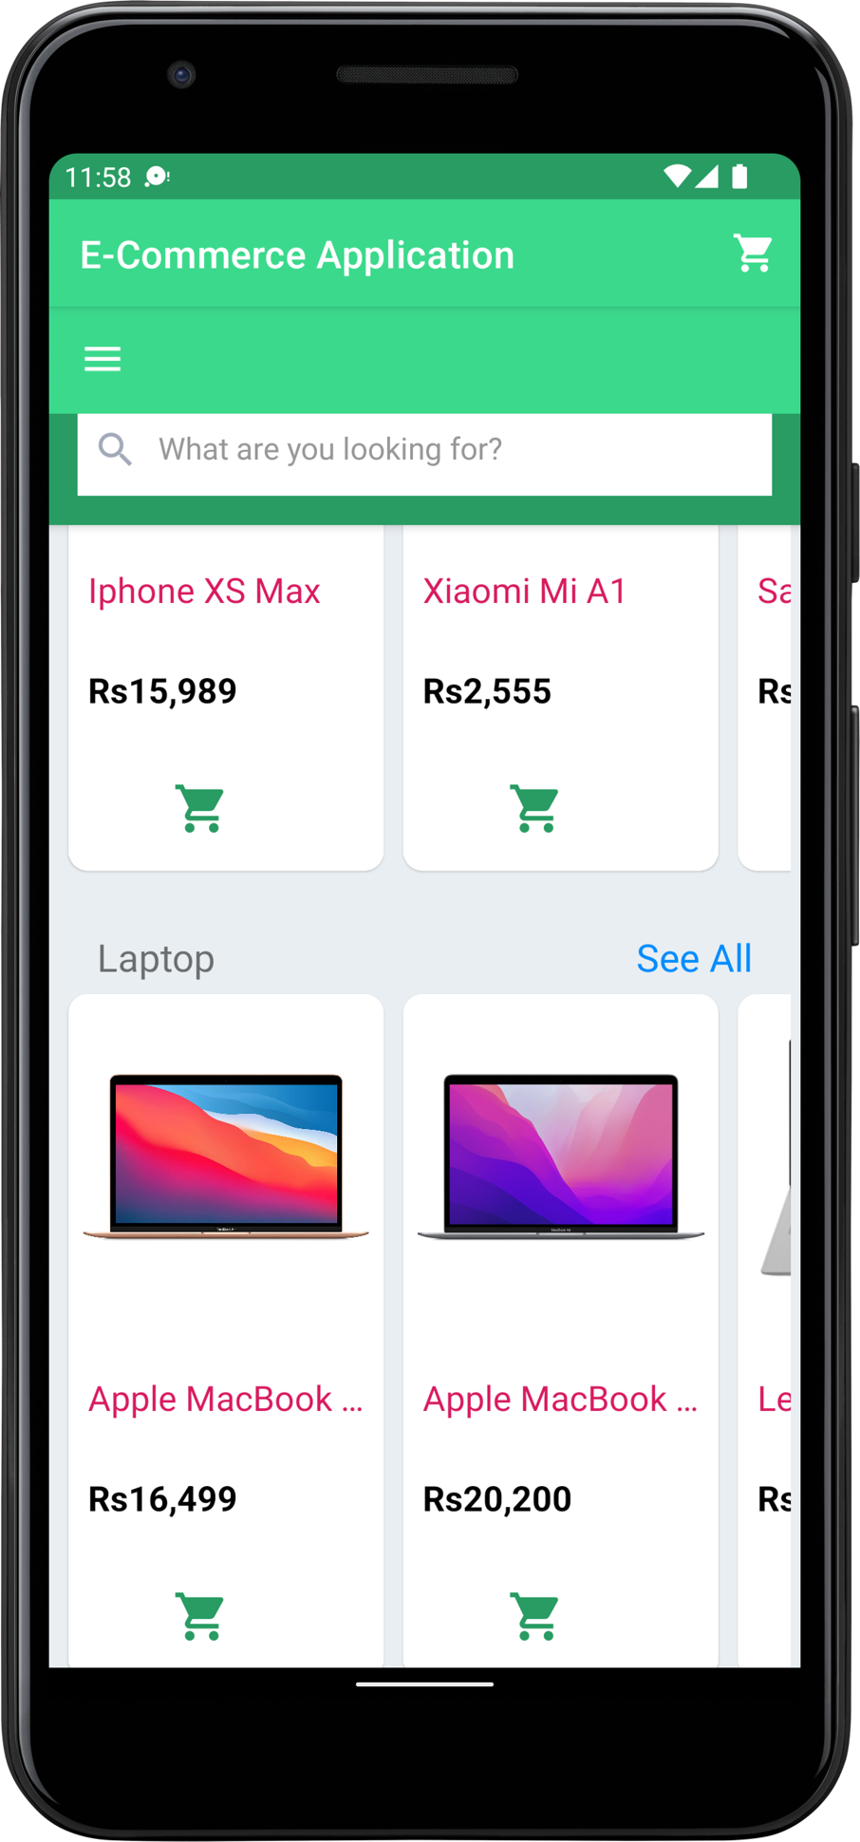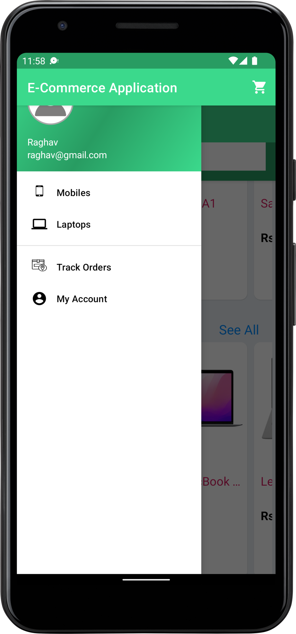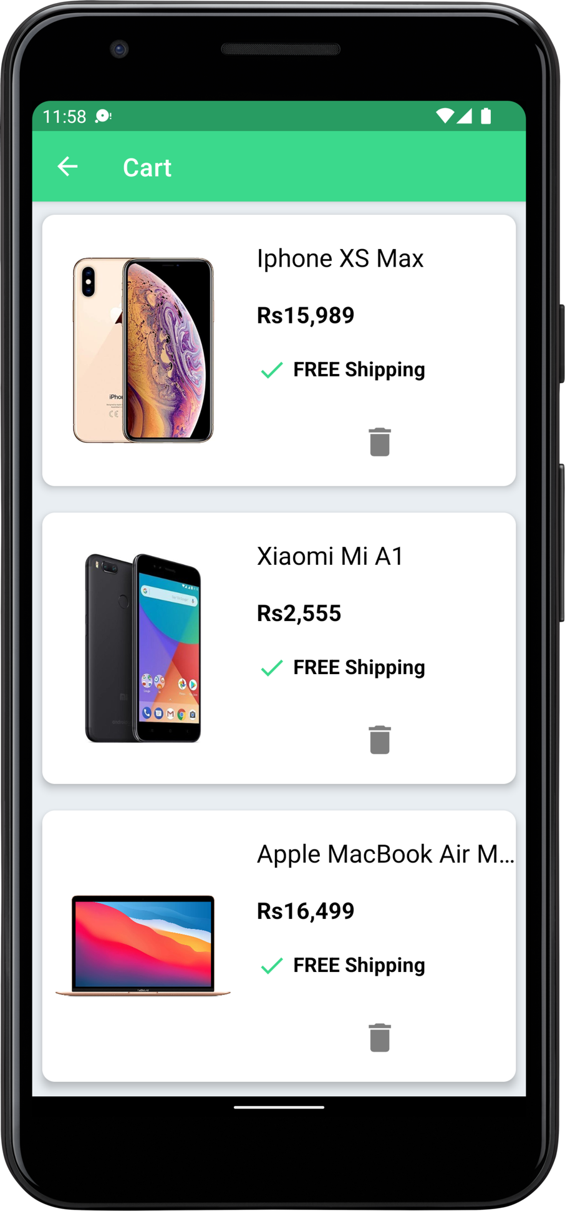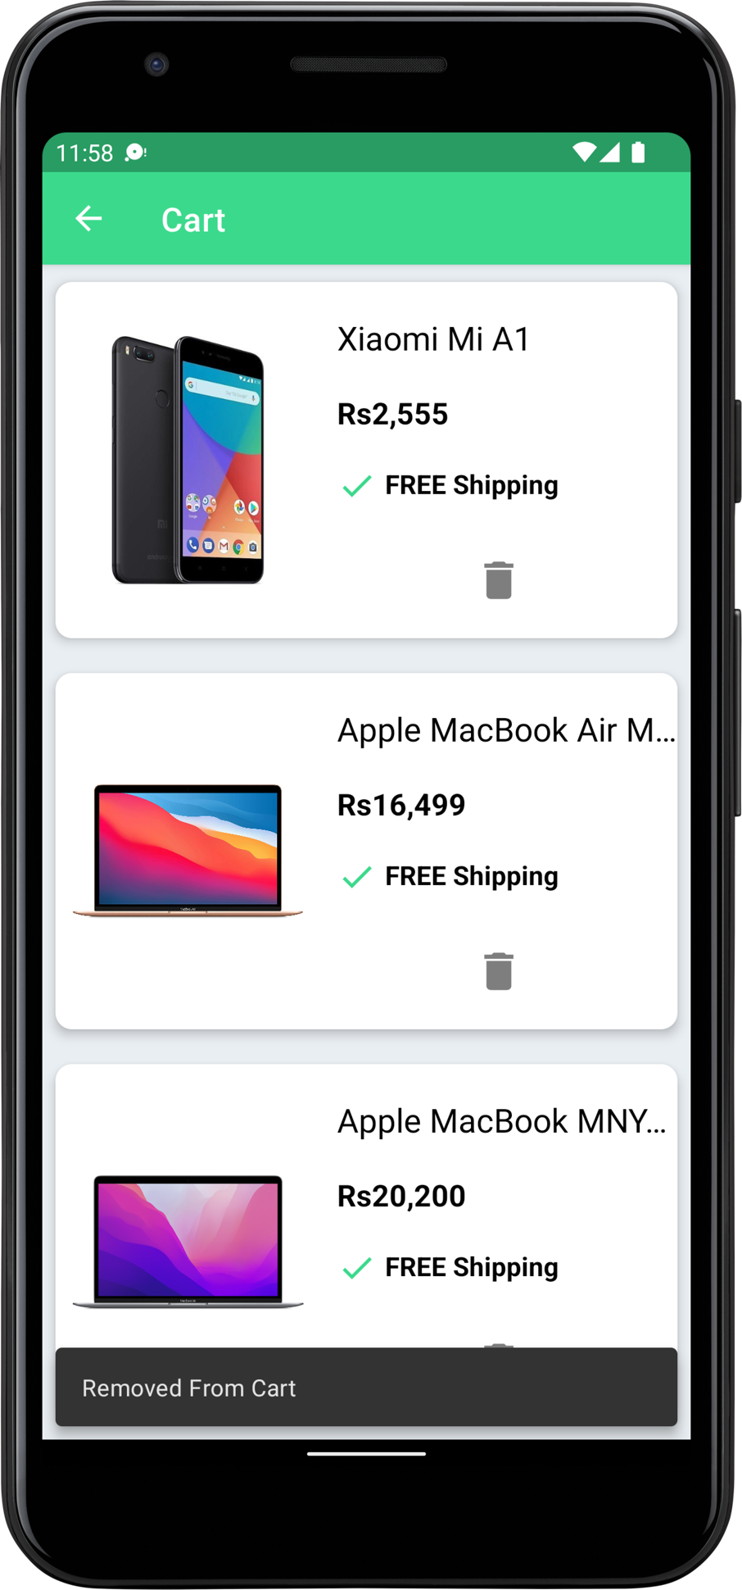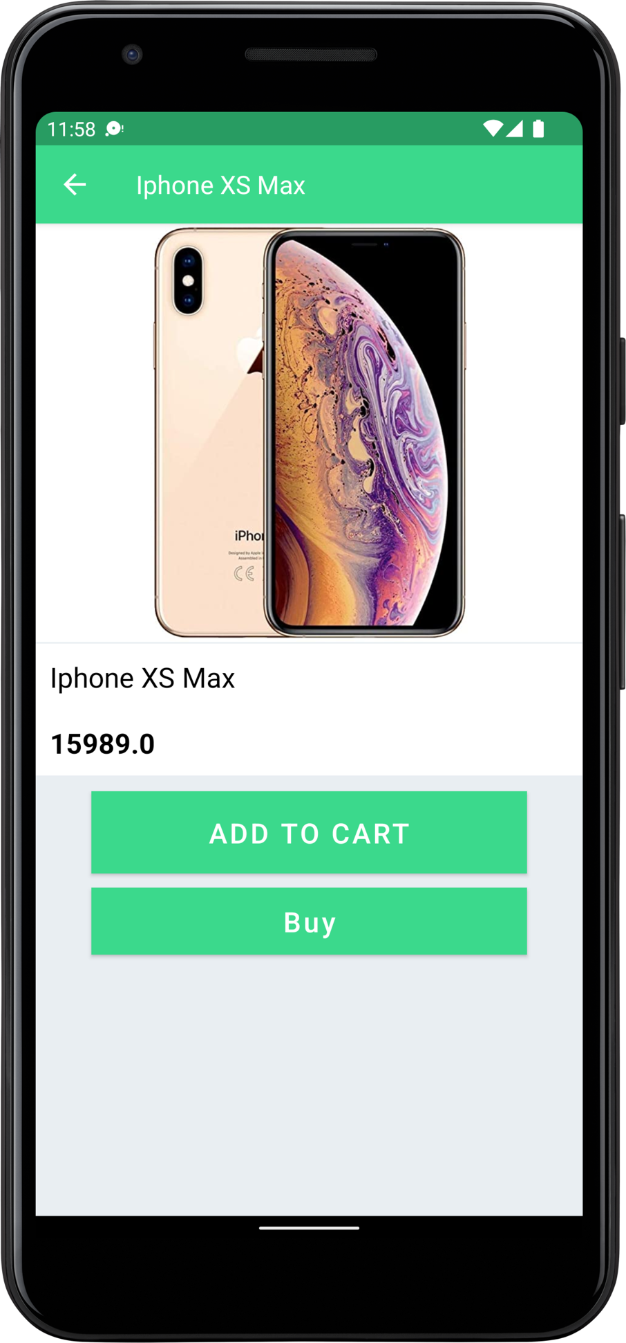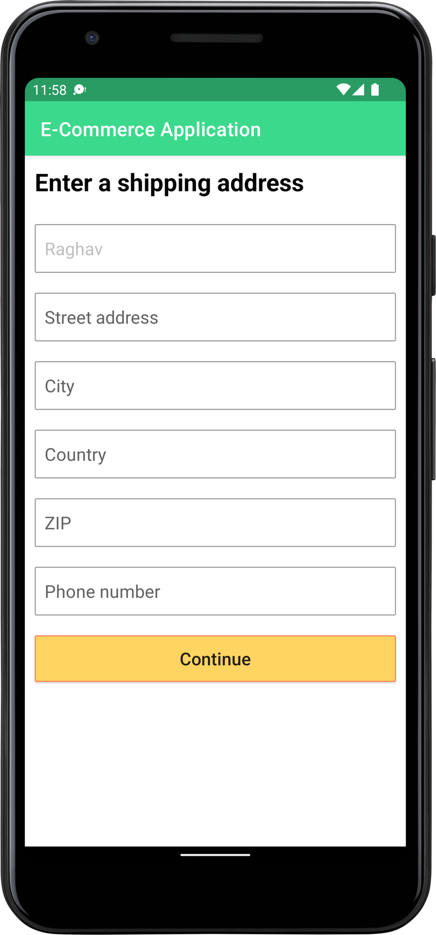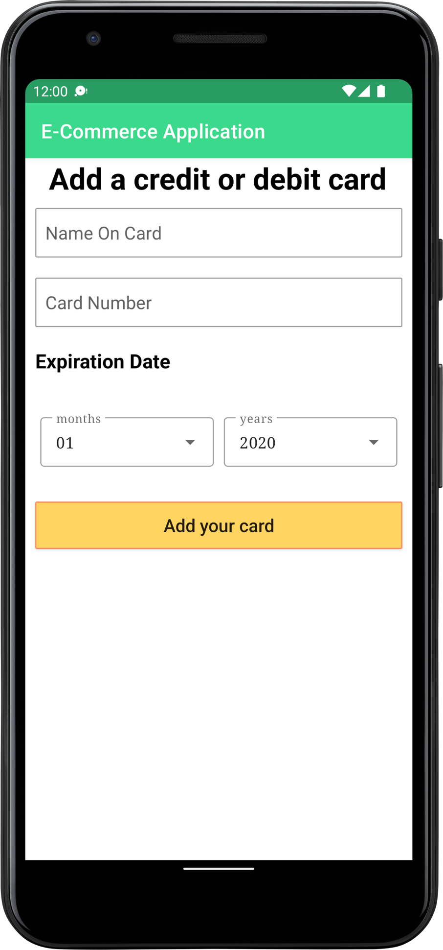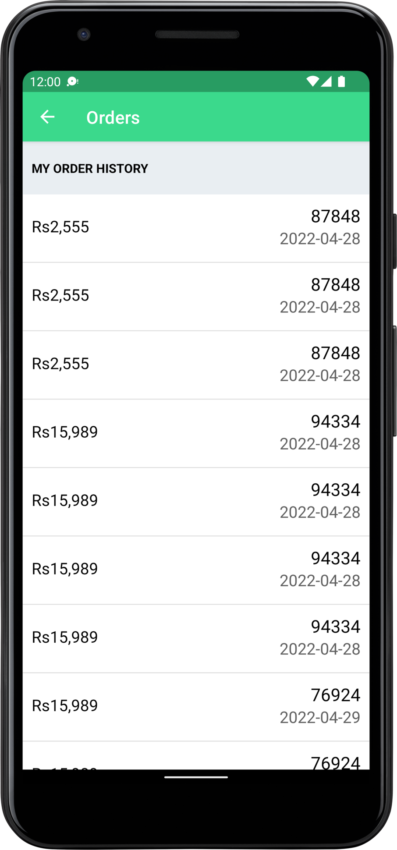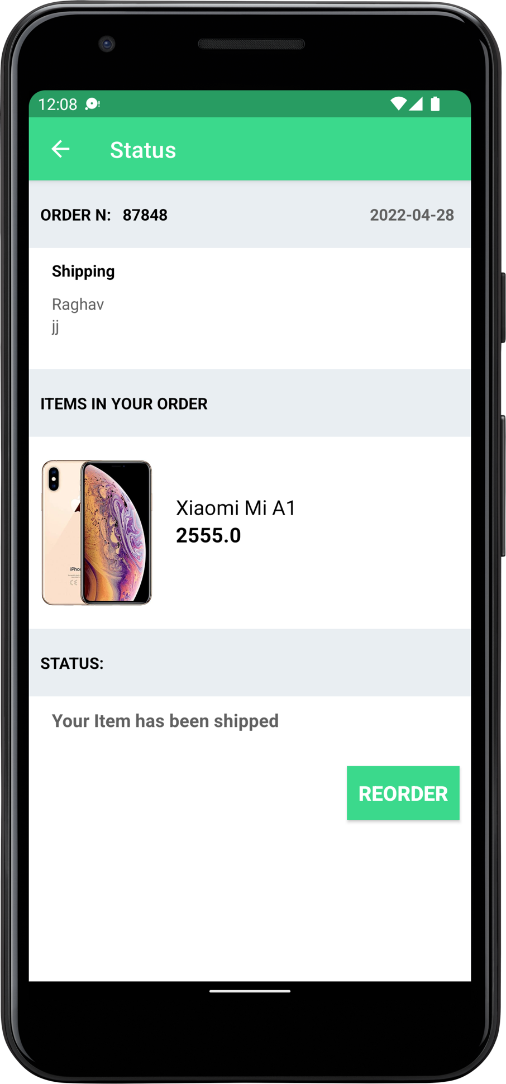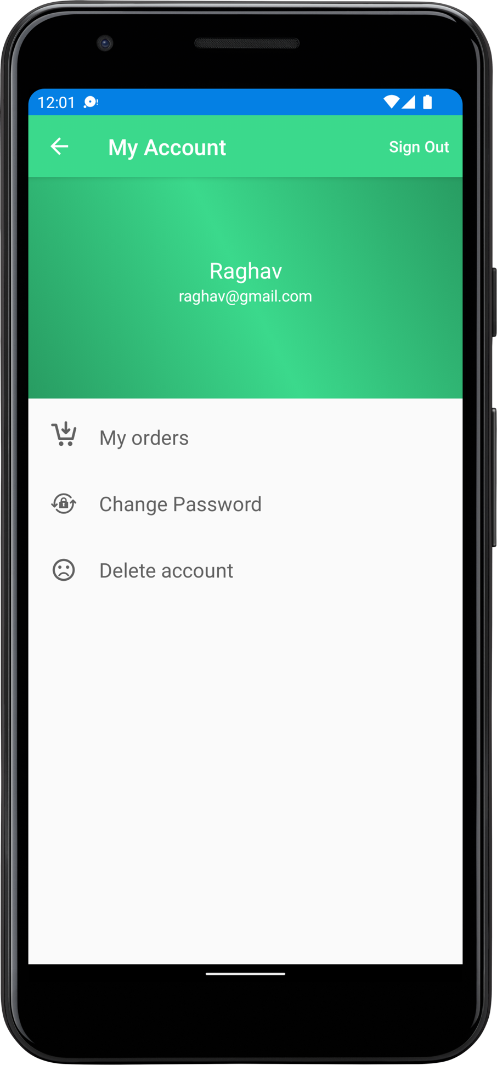

**Team Member Contributions**

|  |  |
| --- | --- |
| **Team Member** | **Contribution** |
| Rahul B | Designed and developed the Hibernate ORM connected it to the MySQL database. |
| Raghav S K | Worked on the Controller and Service and Model layers in the SpringBoot Application along with integration and co-ordination of Models and Repositories in the Client-Side Android Application |
| Rahul Radhakrishna | Developed the Android Application incorporating the Model-View-ViewModel architectural pattern. |

**Conclusion**

**References**